Claims and Evidence
Activity Three: Blackfish Viewing
RHS 1.B: Explain how an argument demonstrates understanding of an audience’s beliefs, values, or needs
CLE 3.A. Identify and explain claims and evidence within an argument
- Previewing Discussions

- Why do people go to zoos and aquariums?

- What is the purpose of zoos and aquariums?

- Do these zoos and aquariums help or injure animals?

- What do you know about killer whales?

- Why are they called killer whales?

- Do you think an animal such as a whale belongs in captivity?

- Do you think that it is dangerous to have a whale in captivity?

Black Fish Notes on the Rhetorical Situation
Scene-describe what is happening | To what does it appeal?  Ethos  Logos  Pathos | How does the director make this?  appeal? (actor’s, visuals, sound effects,  Charts) | How does it affect you?  Is it an effective tool?

Explain the following as they connect to the film:
Exigence

Kairos

Stasis

Discussion Questions

- How does the film begin? What tone do the images establish? How do the trainers being interviewed about their initial experiences affect viewers?
- How does the information from the trial portray the relationships of the killer whales? What was the argument of OHSA? How does it contrast with the Sea World’s perspective?
- Describe the scene in the capturing of the Orcas in Puget Sound in the 1970’s. Why does the director include this?
- How did the capturing of the whale’s impact what happened at Sea Land?
- Why is there such a focus on Tilikum?
- How have orcas been portrayed in film? Is this a realistic compared to the way that orcas act in real life?
- Why if they have not killed any humans in the wild has there been so many incidents in captivity?
- Why is Tilikum separated?
- How are the events in the latter half of the trial portrayed? Whose case do you believe?
- Is the habitat safe?
- What did the researcher find out about vocal whales? What does this illustrate? They were long range vocals looking for her daughter’s moods?
- What was Sea World’s “party line” on trainer injuries?
- What is the storyline on the homeless man who was killed in Sea World at night? What discrepancies in this did the autopsy find?
- Why did they keep Tilikum around?
- Describe the events at Lora Parque in the Canary Islands off Spain. How is this an effective example of pathos?
- How does the letter from Sea World respond to this?
- Sea World claims that the film is not a documentary but in fact an example of propaganda? Do you agree?

Activity Two: Hunting

Step one: Read article one “Proud Kentucky giraffe hunter defends “delicious” kill” and discuss the following questions:
- How is the hunter presented?
- Is this a representation of all hunters?
- How is pathos a central part of the argument in this article?

Step two: Pass out article two “Hunting camp” and have students read and annotate

Ask students to do a two-minute quick write on their response to this. How does this article use pathos in a different way from the first article?

Step three: Show the picture of Theodore Roosevelt have the students respond to the following questions
- What time does this take place?
- Who is the person? What characteristics does this person possess based on the photo? Why?
- What qualities does this reflect of the time?
- How do we view this in our current time?

Step four: Read the article “How this photo of Theodore Roosevelt helped jump start the conservation movement.

Step five: Discuss the questions on the final handout

Videos
Killing Cecil the Lion
https://www.youtube.com/watch?v=vgwHH9oS3IA&disable_polymer=true

Killing a giraffe
https://www.youtube.com/watch?v=vgwHH9oS3IA&disable_polymer=true

Handout one Kentucky Giraffe Hunter article

https://www.huffpost.com/entry/giraffe-hunter-tess-talley_n_5cfa9e22e4b0aab91c0592d6

‘Proud’ Kentucky Giraffe Hunter Defends ‘Delicious’ Kill in TV Interview That Backfires
Tess Talley faced backlash in 2018 when a photo of her posing, smiling and with gun in hand, with a slain giraffe went viral.

By Amy Russo
A Kentucky trophy hunter who sparked global outrage after posing gleefully with a slain giraffe in 2017 spoke out for the first time in her own defense Friday, but she appeared to shoot herself in the foot by raising new questions about what she called a beneficial “harvest.”
In an interview on “CBS This Morning,” 38-year-old Tess Talley described the 2017 South Africa hunt as an environmental effort, but a photo that went viral in 2018 that showed her holding a firearm and grinning in front of the carcass prompted a backlash.
Help us tell more of the stories that matter from voices that too often remain unheard.
Talley used the skin of the giraffe to cover a gun case and throw pillows, which she said, “everybody loves.”
“He was delicious,” she said. “He really was. Not only was he beautiful and majestic, he was good. And we all take pictures with our harvest. That’s what we do. That’s what they’ve always done. There’s nothing wrong with that.”
The picture caught fire on social media after it was resurfaced and shared on Twitter by digital news outlet Fairlands’s. It was then retweeted more than 48,000 times with a caption berating Talley as a “white American savage” and a “neanderthal.”

White american savage who is partly a neanderthal comes to Africa and shoot down a very rare black giraffe coutrsey of South Africa stupidity. Her name is Tess Thompson Talley. Please share
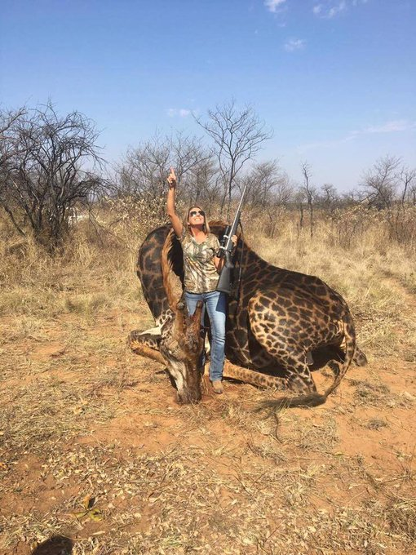

Undeterred by widespread scrutiny and the condemnation of celebrities including comedian Ricky Gervais and actress Debra Messing, who labeled her a “selfish murderer,” Talley described it as a preservation effort.
“We are managing herds,” she said. “We’re managing numbers of wildlife.”
Still, CBS anchors pushed back on Talley’s argument, wondering why she doesn’t simply donate to nonlethal conservation initiatives rather than take matters into her own hands.
“I would rather do what I love to do, rather than just give a lump sum of cash somewhere and not know particularly where that is going,” she replied.
Talley called the hunts “a hobby” and asserted that she remains “proud of that giraffe.”
The International Union for Conservation of Nature’s Red List, which tracks the status of wildlife populations, categorizes giraffes as vulnerable. Major threats to the species include habitat loss, civil unrest, ecological changes and illegal hunting. But in South Africa, hunting remains legal, even though it has been met with shock and anger online.
In a statement released in April, Kitty Block, head of the Humane Society of the United States and Humane Society International, sounded the alarm on threats to giraffes, warning that the U.S. has “played a significant role” by allowing trophy hunters to enter the U.S. with wild animal parts.
“Over the past decade, nearly 40,000 giraffe parts and products were imported into the United States, including giraffe bone knife handles, giraffe skin pillows and more,” Block said. “There are no strong international regulations on the trade in giraffe parts, and giraffe bone has now taken on the status of a ‘new ivory.’”
Despite Block’s concerns, in 2018, zoologist John Hanks, a former Africa program director at the World Wildlife Fund, backed hunting as an important conservation tool.
“There are hunters who hunt ethically, and it’s always the bad side that gets blown up out of all proportion,” he told The New York Times. “Unfortunately, the critics climb on the people who make the mistakes, and vilify everyone for being in the same boat.”

Handout Two: Hunting Camp

https://time.com/5349472/david-joy-hunting-camp/

Memories From the South: Hunting Camp
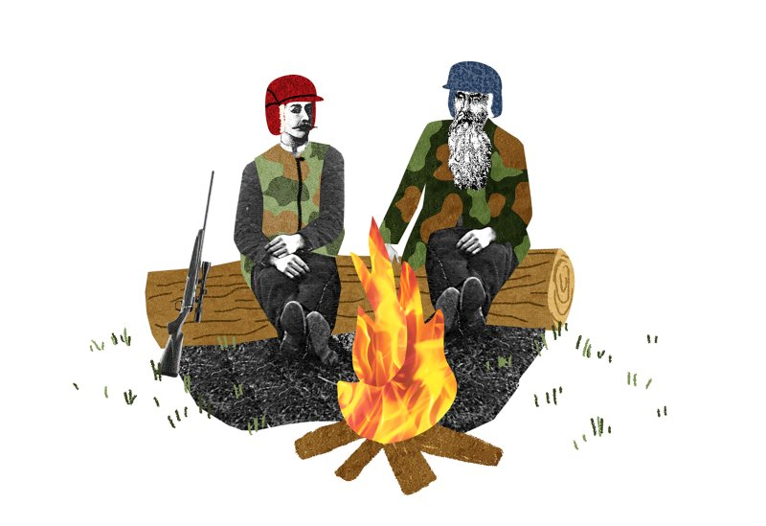
Natalie Nelson for TIME

BY DAVID JOY
JULY 26, 2018
In South Carolina, season opens the first week of October. A few diehards at camp come at the start and stay till the end, but most of us filter in and out whenever time allows. We drive down, go home, work jobs and sneak back on weekends. For three months, life is governed by deer hunting.
Our camp is located in McCormick County. More specifically Plum Branch, a town that is little more than a crossroads. A rutted gravel road cuts between pines to a series of flat-tired, pull-behind campers tarped and covered with tin, a bathhouse, a picnic shelter and a fire pit.
Spread over a few acres, there’s Burt and Carole, Zeno and Diana, Billy and Nancy, Florida Joe, Son in Law, Ted, Shady Grady, Jackie, Randall, Jason, Lewis and me. Sometimes Son in Law’s son-in-law comes with his son. It’s a tongue-twisting maze of names and connections that would be hard to keep straight even if you were there from the beginning.
Most of these men have been coming here since before I was born. They’re in their 60s, a few mid-70s, one inching fast for 80. After 45 seasons wandering the same woods, they’ve come to know the land intimately. They throw around names—the Owl Boxes, the UFO Hole, the Refrigerator Stand—places where they’ve killed deer for decades. At 34, I’m the youngest one here.

Sometimes at night the train goes by, and as the whistle blows the coyotes get to crying and it’s about as lonesome a sound as any of us have ever heard. For a few seconds the stories stop, and we turn our ears away from the campfire to listen. The wood crackles and pops, and Florida Joe pokes at the coals with his walking stick.
Sometimes Zeno Ponder passes around a gallon jug of muscadine cordial. The bottle always stops a little longer when it reaches Son in Law. He takes one sip, glances around, sneaks another. Someone gives him hell and everyone gets to laughing, and, though none of us air a breath of sentimentality, I know it’s been a year since any of us felt this good.
Sometimes the South Carolina boys come to visit—Jim, Gary, Mark, Spike and Ugly Buck. Once a season, Jim brings a giant pot of chicken and rice. It’s a dish we look forward to same as Florida Joe’s cornbread, Son In Law’s potatoes and onions or Nancy’s cheesecake. We scrape the pot clean and lick our plates knowing every time may be the last because Jim’s beat cancer once and has cancer again. Even the toughest men don’t last forever.
Two years ago we spread Larry’s ashes under the rocks circling the fire. Larry lost one of his legs to a landmine near Ben Luc, pulling patrols along the Mekong River. He had a prosthetic, but that never stopped him from working a climbing stand 20 feet up a pine. It was his liver and heart that failed him. Agent Orange. A large portion of camp served in Vietnam.
Aside from Florida Joe and Billy from Texas, everyone at camp comes from the Blue Ridge Mountains. Jackie’s the one first brought me here. He and I ride together from Jackson County, North Carolina. The pine flats of South Carolina are a different landscape altogether from the mountains where we live. This is where the piedmont transitions to sand hills. The sun is relentless and there is seldom a drop of rain. But there are deer here, more than we could ever hope to find back home.
I come from a family of small-game hunters, so it was the men and women at camp who taught me to hunt deer. Jackie Medford showed me how to read sign, scrapes, rubs and licking branches. Last November, Burt Hogsed gave me the tree where I would later kill my biggest deer to date. Zeno Ponder was the one who first handed me a knife and told me where to cut. Any gap that may exist in age is bridged by a deep belief that there is something greater than mere subsistence gained from time afield.
For the most part, ours is a culture on the brink of extinction. Fewer are finding their way into the sport, and every year there is less land to roam. More than just the hunting, though, what we hold on to is a microcosm of what the growing urban-rural divide has erased across much of the rural South. It’s that old-time communion that used to be commonplace.
The meals we share are no different than what used to be Sunday suppers. The storytelling around the fire used to be front-porch affairs. The large, extended families that filled church pews, the kinds of families with tongue-twisting mazes of names and connections, don’t hold together like they did in the past. Kids move away and seldom return. The fellowship halls where people gathered for reunions are empty. The family graves are grown over with weeds. But there are holdout pockets where story still matters and people are still tied to the land.
At camp we hold on to tradition, and as the moon rises behind the pines, the old men talk and I listen. Deep down I know it won’t last, that it can’t, so I linger on every word. If time favors us all the same, there will come a season when I am alone. Sooner or later, there will come a night when the last of the fire burns out.
Joy’s latest novel, The Line That Held Us, comes out Aug. 14
This story is part of TIME’s August 6 special issue on the American South. Discover more from the issue here.

Handout three: picture of Theodore Roosevelt
https://time.com/5259995/theodore-roosevelt-portrait-conservation-hunting/

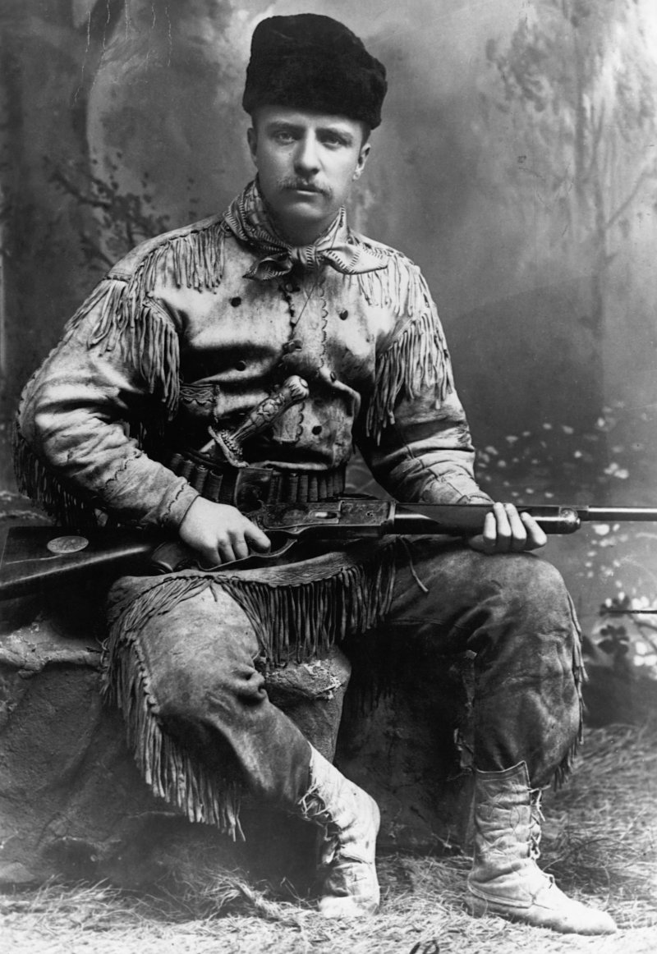
A portrait of Theodore Roosevelt (1858-1919) in buckskin, without his trademark glasses. This portrait is dated 1885, the year he retired to his ranch in the Dakota Territory, following the death of his mother and first wife.
Historical/Corbis/Getty Images

HANDOUT 4: aRTICLE ON tHEODORE ROOSEVELT
BY PHILIP DRAY
MAY 1, 2018
The studio photograph of Theodore Roosevelt in a buckskin hunting costume, rifle at the ready, remains one of the most iconic images of the American conservation movement. That he looks ready to kill something is no affectation; Roosevelt was a gung-ho hunter all his life. Yet his legacy is so much larger, as was the principled example he lived, of the compatibility of hunting wildlife and the protection of wildlife and wilderness. It was a synthesis that would define not only his efforts, but the nascent conservation movement that he came to symbolize.
Born in 1858 in New York City, he was the son of Theodore Roosevelt Sr., a founder of the American Museum of Natural History; the museum charter was approved in 1869 in the front parlor of the family brownstone on East Twentieth Street. Theodore’s father, in response to his son’s childhood asthma, urged the boy toward an outdoor, athletic life. The son was duly swept up by the works of James Audubon, William Bartram, and Alexander Wilson, as well as the boy-hunter novels of Mayne Reid, and came to know the books of Frank Forester, although he looked askance at Forester’s aristocratic fussiness about purebred hounds, cognac and the nomenclature for groups of ducklings.
Roosevelt, by contrast, would cultivate the twin modes of frontiersman and exacting naturalist. To improve his ornithological study and sketching, he sought tutoring in basic taxidermy and, at age 12, shot a number of winged specimens while on a family trip to Egypt. He hunted and developed his expertise as a natural scientist in the Adirondacks, but a truer apprenticeship began in 1884, after his young wife, Alice Hathaway Lee, died in childbirth. Brokenhearted, he put his nascent New York political career on hold and, with no certain date of return in mind, left the East to grieve alone in the Badlands of the western Dakotas.
As for many a tenderfoot, one of the first impulses Roosevelt acted on was to shoot a buffalo, and over the next several years he added numerous other trophies—a bighorn sheep, a 1,200-pound grizzly bear, as well as a mother bear and her cub. He also invested about $80,000, half of his inheritance, in a cattle ranch, much of which he lost over the hard winter of 1886–87, when tens of thousands of cattle across the region froze or starved to death. While a touring correspondent for the Pittsburgh Dispatch found him “a pale, slim young man with a thin piping voice and a general look of dyspepsia about him . . . boyish looking . . . with a slight lisp, short red moustache and eye glasses . . . a typical New York dude,” Roosevelt was determined to attain a rugged manhood that would require no caveat about his big city origins or his being a son of privilege.
He became a western ranchman by sheer force of will, developing passable skills as a rider and hunter, once even leading a posse to capture three armed thieves who had made off with his rowboat during a spring flood. His exuberant love of the chase was integral to his identity, and he honored it with his wardrobe, ordering a fine buckskin outfit made in the mode of his heroes Daniel Boone and Davy Crockett. This was the suit he posed in, complete with moccasins, rifle and sheath knife, to promote his 1885 book, Hunting Trips of a Ranchman. The image couldn’t help but appear dubious to anyone who knew his upbringing, and later, when he became famous for his hunting, critics would mock him as a boy who never grew up, or as someone with an inordinate need to kill living things. Of course, it would never have struck Roosevelt himself that he looked the poseur: the photograph was a sincere representation of his belief not only in what he was, but the kind of person he thought all American men should aspire to be.
His hunting was prodigious. He took pride in shooting large tallies of birds and other fauna and securing significant trophies, some of which, as a naturalist, he termed “specimens.” But to Roosevelt, the hunting of wild creatures and the taking of animal hides and horns was always about something greater—a primal reconnect with the natural, precivilized world and “the free, self-reliant, adventurous life, with its rugged and stalwart democracy.” Hunting was not merely recreation but a transformation, one with stages of apprenticeship, youthful testing and eventual self-mastery.

Roosevelt’s path to prominence in the cause of wildlife preservation began, strangely enough, with a comeuppance he experienced at the 1885 publication of Hunting Trips of a Ranchman. The book was for the most part well received, but one very mixed review came from George Bird Grinnell, now the editor of Forest and Stream, who had replaced the brilliant but intemperate Charles Hallock. While commenting favorably on Roosevelt’s skills as a New York state politician and his interest in the West, Grinnell suggested that as a newcomer to the region he had missed some of its subtleties. “We are sorry to see that a number of hunting myths are given as fact, but it was after all scarcely to be expected that with the author’s limited experience he could sift the wheat from the chaff and distinguish the true from the false,” Grinnell wrote, allowing that the book’s naïveté lent it a certain charm.
It was this damning-with-faint-praise that got under Roosevelt’s skin most, and the indignant author immediately presented himself at the Forest and Stream offices to demand an audience with his critic, whom he had never met. After a lengthy conversation, he was honest enough to acknowledge that in Grinnell, who like him came from an old and affluent New York family, he had met his better, at least as far as the West was concerned—a man, after all, who had ridden with Custer, lived among the Cheyenne, and dug for relics under the gaze of Othniel Marsh. The styles of the two, who soon became friends, proved complementary, Grinnell an older, more sophisticated, methodical, less restless version of Roosevelt, who awoke each day eager to grab life by the lapels.
Out of their conversations and correspondence grew the idea for the founding in 1887 of the Boone and Crockett Club. The purposes of the organization, to comprise hunter-naturalists, were to “promote manly sport with the rifle,” create an exchange of information about big game and where it could be found, spread the ideals of ethical hunting and an interest in natural science, and advocate for wildlife preservation and related legislation. “Although hundreds of sportsmen’s associations with a similar goal were already in existence,” notes conservation historian John F. Reiger, “too many of them were concerned only with local wildlife conservation or spent more time talking about protecting game than in actually working for it.” One immediate opportunity for the organization resulted from the newly federally enacted Dawes Severalty Act, which broke up large Indian reservations for the purpose of making individual property allotments to Native Americans; the act also made available millions of acres of former tribal lands for purchase by non-Indians. The Boone and Crockett Club, whose roster included elite sportsmen from New York’s financial industry, jumped at the chance to secure some acres as game refuges.
“All hunters should be nature-lovers,” declared Roosevelt, chosen as the club’s first president, in paraphrase of the organization’s purpose. “It is to be hoped that the days of mere wasteful, boastful slaughter are past and that from now on the hunter will stand foremost in working for the preservation and perpetuation of wild life, whether big or little.”
Within a decade of its founding, however, with the worsening crises of species displacement and loss, the club was forced to pivot dramatically. “Founded as an association of amateur riflemen,” Grinnell recalled, “it became apparent that large game was disappearing so rapidly that unless measures were taken . . . there was danger many specimens would be exterminated. Thereby (its) purpose . . . became gradually modified . . . and grew to be a club more interested in conservation than killing.” The new emphasis on restraint was soon visible. “Those who used to boast of their slaughter are now ashamed of it,” he said, “and it is becoming a recognized fact that a man who wastefully destroys big game, whether for the market, or only for heads, has nothing of the true sportsman about him.”
In a sense, it was the sport hunter’s own ethos of civilized hunting—what the Boone and Crockett Club termed fair chase—which had brought them here. The good hunter’s appreciation of wild places, his respect for the game he hunted, for the rules of fair play and observed hunting seasons, all had led directly to this looming project, as daunting as it was grand: scientific game management and conservation.

Handout five: discussion questions
Discussion Questions:
- The initial article creates a negative portrayal of hunters. Is this unwarranted or representative?
- How does Joy use nostalgia and anecdote to make an impression?
- What beliefs do you share with the author or do you differ which affect your reading of the piece?
- What is the metaphor of the piece? What does hunting represent? How does ending with a metaphor emphasize Joy’s point in the piece?
- What is the Joy’s thesis? Is this explicitly or implicitly stated?
- How does the picture of Theodore Roosevelt create an impression? What values do you think the audience is expected to associate with the picture?
- How do allusion and history represent a key element of argument in the Dray’s article?
- What myths does it establish? How is ethos a central part of the piece?
- In the end Dray offers a comparison with the term fair chase? How is this significant to the story? End the end does the article challenge any beliefs that society may have about hunting?

Activity Three: Debates of Issues involving Animals
Directions
- Each person should read at least 4 of the articles for your group use the links for your topic. You may find any other articles on the topic you want. You are not limited to these articles.
- List the three most important factors to consider in making a decision on your group’s position
- Write a statement of your position on the argument (the position you are given)
- Write an introductory paragraph (the issue, the context, why you think it is important, what your position is and why)
- Write one body paragraph
- Includes a thesis statement (claim)
- Includes examples from two of the documents (evidence)
- Explains why those examples connect to your argument in this paragraph (analysis)
Post parts 2 through 5 to google classroom by the beginning of the period of your debate day
Everyone in your group will have to go during one of the rounds
You group will be assigned to be pro or con on one of the following topics
Zoos
Pro: Zoos should remain as a vital part of society.
Con: Zoos should be eliminated because they do not serve a vital function in society.
Animal Testing
Pro: Animal testing should continue because it is necessary.
Con: Animal testing should be eliminated because it is not necessary
Spending Money on Pets
Pro: Spending excessive money on pets is unethical.
Con: Spending money on pets is ethical.
Trophy Hunting
Pro: Trophy hunting should be continued because it serves a necessary function.
Con: Trophy hunting should not continue because it does not serve a necessary function.
Endangered Species Act
Pro: The Endangered species act as it has existed is a necessary function of government.
Con: The endangered species act does not serve a necessary function and should be lessened.

Debate Roles and Responsibilities
*proposition is pro *opposition is con *Constructive can contain new argument *Rebuttal cannot add any new arguments
Speaker | Time | Responsibilities
First proposition constructive | 3 minutes | - Defines the issue  - Lays out relevant details to issue  - Makes 3-5 new arguments provides evidence for those arguments
First opposition constructive | 3 minutes | - Lays out details of counterarguments  - Makes 3-5 arguments  - Refutes first proposition’s arguments  - Poses questions for proposition
2nd proposition constructive | 3 minutes | - Restates issue  - Rebuilds first proposition’s case with new evidence  - Adds 1-2 new arguments  - Refutes first opposition’s argument  - Responds to opposition’s questions  - Poses questions for opposition
2nd opposition constructive | 3 minutes | - Restates counter case if there is any  - Rebuilds the first opposition’s arguments with new evidence  - Adds 1 or 2 new arguments  - Refutes all the proposition’s arguments  - Responds to questions  - Poses questions
Opposition rebuttal | 2 minutes | - Answers any questions  - Points out most important argument (summarizes evidence)  - Explains weaknesses in proposition case  - Explains why opposition has won debate
Proposition rebuttal | 2 minutes | - Answers any questions  - Points out most important argument (summarizes evidence)  - Explains weaknesses in opposition case  - Explains why proposition has won debate

Scoring Guide for Debates (Teacher)
Member Names
Position and Topic: Grade
Category | Inadequate | Adequate | Effective | Exemplary
Overall Score
Knowledge of the Readings  And paragraphs | Little evidence of readings  0-7 | Shows knowledge of readings and key ideas  8 | Effectively supports ideas through examples from readings  9 | Displays thorough knowledge of readings by synthesizing information from multiple sources  10
Initial Arguments | Unclear arguments  0-23 | Clear and logical arguments  24 | Thoughtful and well supported arguments  27 | Insightful and persuasive arguments  30
Response to Other Teams | Little knowledge of oppositional arguments and ability to respond  0-23 | Careful knowledge and ability to respond; signs of active listening  24 | Responds to and critiques/elaborates on other teams’ positions  27 | Sophisticated analysis, critique, and elaboration upon the arguments of other teams  30
Final Response | Limited summation of key points  0-23 | Addresses ideas clearly  24 | Effective and thoughtful expression of ideas with support  27 | Sophisticated explanation of ideas with a convincing argument  30

Debate Scoring Guide (Students) Which side won? PRO CON
PRO Side Members
Initial Arguments | Unclear arguments  5 | Clear and logical arguments  8 | Thoughtful and well supported arguments  9 | Insightful and persuasive arguments  10
Response to Other Teams | Little knowledge of oppositional arguments and ability to respond  10 | Careful knowledge and ability to respond; signs of active listening  16 | Responds to and critiques/elaborates on other teams’ positions  18 | Sophisticated analysis, critique, and elaboration upon the arguments of other teams  20
Final Response | Limited summation of key points  14 | Addresses ideas clearly  16 | Effective and thoughtful expression of ideas with support  18 | Sophisticated explanation of ideas with a convincing argument  20
Total
Category | Inadequate | Adequate | Effective | Exemplary
Overall Score
Con Members
Initial Arguments | Unclear arguments  5 | Clear and logical arguments  8 | Thoughtful and well supported arguments  9 | Insightful and persuasive arguments  10
Response to Other Teams | Little knowledge of oppositional arguments and ability to respond  10 | Careful knowledge and ability to respond; signs of active listening  16 | Responds to and critiques/elaborates on other teams’ positions  18 | Sophisticated analysis, critique, and elaboration upon the arguments of other teams  20
Final Response | Limited summation of key points  14 | Addresses ideas clearly  16 | Effective and thoughtful expression of ideas with support  18 | Sophisticated explanation of ideas with a convincing argument  20
Overall Score
Activity Four: Argumentative Essay on Animal Dignity
2.B: Demonstrate an understanding of an audience’s beliefs, values, or needs.
4.A: Develop a paragraph that includes a claim and evidence supporting the claim.
4.B: Write a thesis statement that requires proof or defense and that may preview the structure of the argument.

Directions:
Step One: Handout out the prompt Handout One. Read over the prompt with students. Have students annotate the prompt. Tell them to make sure that they understand what the prompt is asking them to do. (This activity could be a practice essay, or you could have the students just do the handouts as preparation/practice for writing an argumentative essay. As preparation you might also select to have the students work in pairs).
Step Two: Pass out Handout Two. Explain thesis writing to students. Explain the importance of defining terms before beginning with an argument. Have students write out their definitions of animal dignity. Discuss these with students-have students think about what makes a complete definition. There are three types of definitions: dictionary, extended, and operational. This definition would be an extended-a personal definition and an operational—a definition which explains how something functions in society. For further information on this follow the explanation of extended definitions and the link to a video on operational definitions. This type of definition is a form of a logical appeal.
Step Three: After students have written their thesis statements, I have students look at three basic components of the thesis and focus on writing each of them clearly: the topic, their position, and a reason why they believe this. More information on thesis writing can be found here. Have students write their thesis.

Step Four: Pass out Handout Three. Have students fill in the chart focusing on claims, data, and analysis. Point out that the analysis portion is especially significant for a successful essay-explaining how the evidence supports your claim is important but something students frequently neglect. Give students time to fill out the chart and organize the paper. Graphic organizers such as this are essential as many students have a difficult time writing their essay; graphic organizer serve as a pump to help them generate ideas.

Step Five: Students write their draft of the essay—if you are using this as preparation for an essay you might have students work in pairs and write the introduction and one body paragraph. This type of assignment I would make an in-class writing, although if it is early in the year you might allow students to draft it in class and then give them an opportunity to revise at home.

Handout One: Argumentative Essay on Animal Dignity Prompt
Rough Draft Due 4pm September 27th (you will have lab time to do the paper in class)
2nd Draft due 4pm October 4th (you will have lab time to do the paper in class)
Essays should be

In a January 13, 2014 editorial in the New York Times, columnist, Frank Bruni writes:

The Dodo’s pedigree speaks to a broadening, deepening concern about animals that’s no longer sufficiently captured by the phrase “animal welfare.” An era of what might be called animal dignity is upon us. You see signs everywhere.
A story in The Wall Street Journal on Sunday reported a sharp rise over the last few years in the fraction of American dog and cat owners with provisions in their wills for their pets. Nearly one in every 10 have made such arrangements.
One of the most fervently embraced documentaries of 2013 was “Blackfish,” shown over and over on CNN. It doesn’t just depict mistreatment of killer whales at SeaWorld; it makes the case that these glorious mammals have rich social and family connections and a profound capacity for grief.

Consider the emphasis which Bruni places on the value of “animal dignity.” Consider Bruni’s contention that we are entering an era that might be called one of “animal dignity.” Take a position which supports, refutes, or qualifies the claim that we should foster animal dignity in our society. In your essay define what it means to have dignity for animals and if this should occur. Use evidence from your readings, your observations and experience, and/or the media to support your position. In your essay you may consider topics such as:
- Is it right to hunt animals?
- Should animals be tested for science?
- Are zoos ethical?
- Should we have animals as pets?
- Should hunting of animals be eliminated?
- Should we preserve endangered species?
- Should we euthanize animals who were pets and do not have owners?

Handout Two: Thesis for Paper on Animal Dignity
Step one: write out two sentences in which you define what “animal dignity” means.

Write a clear thesis which states your position on if we should be a society which fosters “animal dignity.”

Handout Three: Graphic Organizer for Claim, Data, and Analysis

Supporting Claims, Reasons  Reasons should support your position on fostering animal dignity in our society  (Claim) | Evidence (two examples) list the example to be used  (Data) | Where does evidence come from (readings—nonfiction/fiction-- history, psychology, science etc.—observations and personal experiences, media—televisions, movies, internet, music)?  (Data) | Type of appeal  Cause and effect; definition; syllogism; analogy; emotion; value; credibility; authority | Is this effective? Will people accept the claim? Explain how the evidence supports the claim regarding fostering animal dignity in society  (Analysis)

Handout Four: Organization of Paper
Introduction | Elements in your introduction:  Establish the context/background for your topic—what is animal dignity?  State your thesis—what is your position on animal dignity  Provide a map-guide to where you will take your readers—highlight the key ideas/supporting reasons you will be discussing in the rest of your paper | Notes ideas for starting
Body— | Claim—supporting reasons connected to your thesis  Data—evidence, examples at least two per supporting reason  Analysis—explains how examples support claim regarding animal dignity in society | Notes— (this section is covered in handout three)
Conclusion: | Explains why the reader should support your views and why your position on “animal dignity” is convincing.  Call to action. Tells the readers what they should do because of your argument about animal dignity. | Notes

Handout Five: Peer Editing Sheet
- Does the paper respond to the issue raised about dignity? Where in the argument does the author establish the thesis? Is the thesis clear establishing the topic, the position, and the reason why the author takes that position?

- What words or sentences does the author use to establish those claims? Are those words and sentences clear and appropriate or would you suggest altering?
- What kind of evidence (e.g., facts, anecdotes, analogies, statistics, examples, details, illustrations, expert opinions, personal observations, personal experiences, testimony, or experiments) does the author use to support their claim? Are these pieces of evidence effective in connecting to the issues of education? Why or why not?
- How does the author’s choice of evidence reflect the rhetorical situation (audience, purpose, context) and advance their purposes? Why would the audience be persuaded by this evidence?
- Select one piece of evidence. What is the function (e.g., to illustrate, to clarify, to set a mood, to provide an example, to associate, to amplify or qualify a point) of evidence in their argument, and how do they convey that function? Is this effective?
- Does the evidence reflect at least two of the different types of logical appeals (definition, syllogism, cause and effect, analogy, narration)? Which two? Are these appropriate?
- How does the author’s commentary establish a logical relationship between evidence and the claim it supports? Is this appropriate and convincing or does it need more commentary to fully explain the connection between evidence and claim?
- Has the author effectively connected to the key issues involving animals and brought those issues into the paper?
- How does the paper flow from issue to issue? Is the introduction effective? Does the paper include an effective conclusion which ties the argument together and illuminates the paper’s overall position?
- Does the paper use sophisticated syntax, grammar, and diction? Give examples of particularly fluid language or language which needs to be revised more closely.

Handout Six: Rubric for Animal Dignity Argumentative Essay
Element | 0-6 points  1 Inadequate | 7-8 points  2 Adequate | 9 points  3 Effective | 10 points  4 Superior
Argumentation and Evidence  X4 | Inadequately incorporates evidence from media, reading, and experience; the author’s thesis may be missing or fail to take a clear position on fostering animal dignity in society | Adequately incorporates clear arguments with appropriate and sufficient evidence from media, reading, and experience to support the author’s clear thesis on fostering animal dignity in society | Effectively incorporates appropriate and cogent arguments and with effective evidence from media, reading, and experience to support the author’s strong thesis on fostering animal dignity in society | Skillfully incorporates appropriate, cogent and well- developed arguments with effective and vivid evidence from media, reading, and experience to support the author’s insightful and articulate thesis on fostering animal dignity in society
Organization and focus  X3 | Inadequate organization; may lack clear development, focus, or connection between ideas | Paragraphs and sentences flow in an adequate fashion; occasionally may jump off topic or lack a clear pattern to organization | Paragraphs and sentences flow in an effective fashion with clear transitions between ideas; logical organization of paragraphs | Paragraphs and sentences flow in a sophisticated fashion with strong transitions between ideas; logical organization of paragraphs
Voice  X2 | The text does not incorporate individual voice; writing is generic. | Portions of the text incorporate individual voice. | Text incorporates individual voice in sentence variety and style. | Text highlights an original, individual voice in sentence variety, vivid evidence and details, and style.
Grammar, Mechanics, and Formatting  X1 | Major flaws in the category of proper English usage and control of grammar, sentence and paragraph structure, diction, and syntax.  Errors frequently interfere with reader comprehension. | Several minor flaws in the category of proper English usage and control of grammar, sentence and paragraph structure, diction, and syntax. Errors only occasional interfere with reader comprehension. | Demonstrates an understanding of proper English usage and control of grammar, sentence and paragraph structure, diction, and syntax with few errors. Errors do not interfere with reader comprehension. | Demonstrates a sophisticated command of usage and control of grammar of grammar, sentence and paragraph structure, diction, and syntax.

